APPENDIX A: SPRINT DOCUMENTATION TEMPLATE
- Summary data
Team number | 5
Sprint technical lead(s) | Owen and Duncan
Sprint start date | 23/02/25
Sprint end date | 08/03/25

- Individual key contributions
Team member | Key contribution(s)
Eric Shi | AI implementation
Lin Hein | Further UI developments
Owen Chen | Auction programming
Duncan Law | AI implementation
Stuart Baker | Produced sprint documents and notes

- User stories / task cards
Task 1 will allow the players to offer a property they have landed on to the other players, via an auction. This provides them with a more strategic way of playing the game because if they are low on funds, saving for a different property or just don’t want to buy a property, they don’t have to. It also allows the other players an opportunity to purchase a property they otherwise wouldn’t have been able to buy.

For task 2, we wanted to design an auction screen that shows what is happening for the duration of the auction. This creates a more interactive environment for the auction as the players will be able to see who the current highest bidder is, what the highest bid is, timeouts and lots more.

Task 3 touches on a main feature that the client desires, which is at least one AI game player agent. For this to be successful, we will first produce the basic code for it, and test to see what happens. After this, we will develop the AI further. We currently have a good foundation to follow due to prior planning for this.

Task 4 is a development of task 3, and only possible once task 3 has been completed. We decided that the best way for us to tackle the AI game player agent and their behaviour is to first produce an ‘easy’ mode game player agent. We will develop this AI until we are completely happy with how they interact and function during a live game, from where we will consider creating more levels of different sophistication for the AI. Similar to task 3, we have good guidelines to assist development thanks to previous sprints and their tasks.

Our aim for task 5 was to make the game more playable, as sometimes it’s not possible to play for the full duration of a game due to unseen situations arising, or underestimating how long the game will last. To help counter this, we want to add a working pause and quit function to the games UI, either pausing the game or terminating the game at that moment respectively. Hopefully, the quit function will calculate who the winner is based on the current player situations, similar to the abridged versions winning mechanics.

Task 6 is another task that is focusing on making the game more playable. One of the takeaways from the previous sprint was that the time limits for the abridged version were too few and didn’t have enough differences. To improve this, we will allow the players to choose a custom time limit that is best suited to how they wish to play the game, be it a 15-minute limit or three-hour limit, the choice is theirs.

Task 7 builds on a feature we were building on already in sprint 2. We have identified how we can improve the player experience further, and we wish to make the players movement around the board visible in real time. This will stop the players from just jumping around the board upon completion of the dice roll.

Task 8 is part of the ongoing improvements and changes we are making to the UI to make it the best we can and more aesthetically pleasing. The general UI includes the board and the main screen, the start screen and the background and main components, rather than specific actions, such as auctions or players movements.

Task 1: Develop code for auctioning function
Task 2: Produce a UI for the duration of an auction
Task 3: Introduce AI player agent
Task 4: Develop ‘easy’ level for AI
Task 5: Provide a pause and quit function to the players whilst the game is running
Task 6: Improve abridged version by adding custom time limits
Task 7: Improve UI by showing player movement in real time
Task 8: Improve general UI

- Requirements analysis

Task 1 implements the functional requirement found in the rules section of the brief, specifically, rule 11. Mr Raffles wishes for the players to be able to hold an auction for different properties if the player who landed on that tile doesn’t wish to purchase that property. In our implementation of this, we will allow the players who don’t want to participate the option to ‘Pass’, even if they haven’t made one bid. We aren’t sure if this will be against Mr Raffles instructions, so we will ask.

Task 2 is another task that will touch on making the game ‘fun to play’ and have a ‘colourful and intuitive interface’. We have decided that this would be the best way to demonstrate what is happening during the auction for the players, and it will hopefully make the game feel more interactive as well.

Task 3 focuses on a major component of the games brief, one of the most essential and repeated user requirements in the brief - ‘Your program will therefore require at least one autonomous computer player agent’. There are further examples of this requirement, but they all touch on the same thing, which is that having an AI player agent is a must. This mandatory, functional requirement has already been planned for in previous sprints, so we have a solid foundation to build upon. Our UI when starting the game already provides the option of choosing AI players and we have multiple planning/design documents to assist with the code development for this. Our aim is to produce a competent player agent that behaves in a simple, basic way, which in future, we can build upon if time permits. But our main aim a single, quality AI agent, rather than multiple, poorly constructed AI agents.

Task 4 doesn’t explicitly address any user requirement, as the brief states, ‘The game player agent needs to be able to play the game, but it does not necessarily need to be any good at it’. We interpreted this more as an optional requirement to develop different AI agent levels, where they display different levels of sophistication depending on which level was chosen. As this is not mandatory, it is not a priority during development. However, we feel that adding an ‘easy’ level version will make the game more ‘fun to play’ and will also just improve the game generally as it will be more similar to playing against a real person. It also provides with the opportunity to expand in the future and add different levels.

Task 5 is similar to what task 2 touches on, with the aim being making the game have an interface that is more ‘intuitive’. Whilst testing the game as a team, we realised that including this feature would be very beneficial as there were moments when pausing the game would’ve been useful because we wanted to check the code but were conscious of the time limit continuing to count down. We discussed and thought of multiple situations that players may encounter during play where this would be handy, for instance, if they needed to go to the toilet or check on dinner, etc.
This also led to the idea of providing them with a quit function if the players unfortunately needed to terminate the game prematurely. We decided to include a winner if this was the case, decided the same way as if they had reached the time limit of an abridged game.,

Task 6 again touches on making the game more ‘fun to play’, and in general makes the game more playable and accessible. We found that in the latest version, the time limits available were too limiting to the players, and wanted to provide them with the opportunity to begin the game with whatever time limit they desired. To implement this, we will remove the three preset time limits and replace it with the ability for the player to set their own custom time limit.

Task 7 is an improvement of our previous improvement regarding the player’s position. We believe that this new advancement will enhance the games ‘intuitiveness’. One concern we have for this feature is what duration to set the animation to. We don’t want to have the game token move too slowly or too fast, as this improvement could end up becoming a negative addition to the game. We will have to determine the fine line between fast and slow, most likely through trial and error, and we are considering checking with one of Mr Raffles representatives as we can’t find any specifications in the brief regarding this matter.
Our final task is task 8, which is just to continue with our UI development. We think the game already addresses the ‘colourful’ aspect Mr Raffles is after, but there are areas to improve upon, such as not having overlapping information and text.

- Design

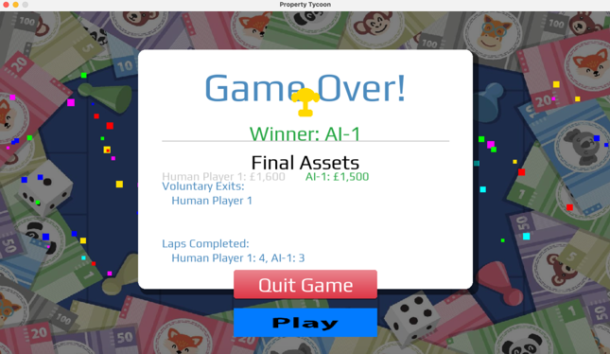
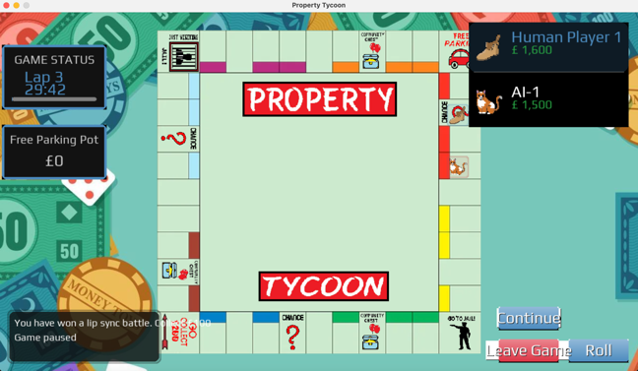
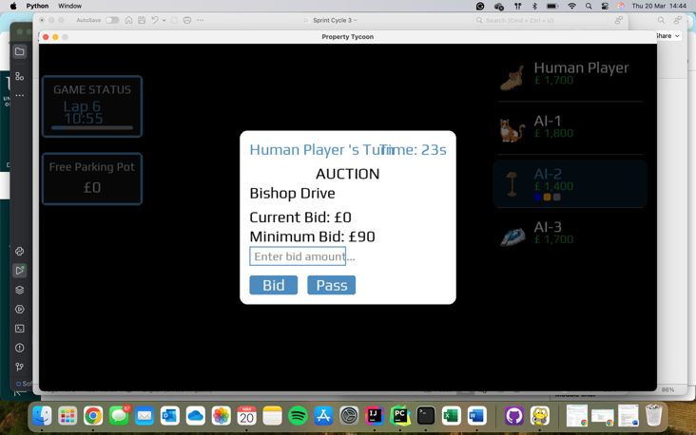
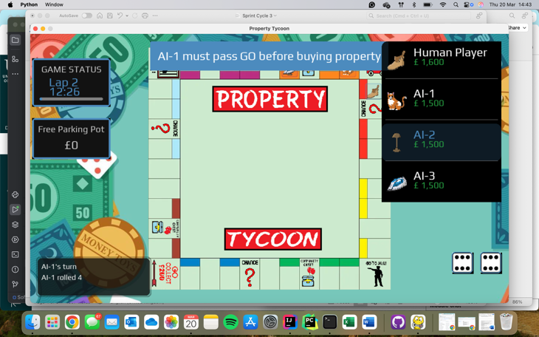
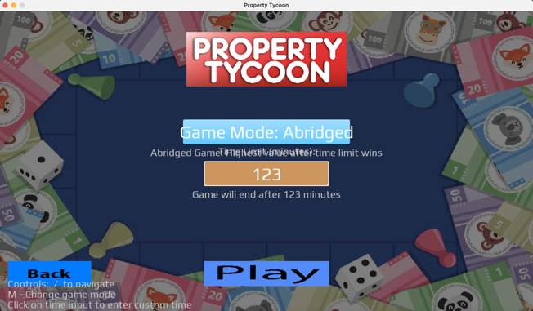
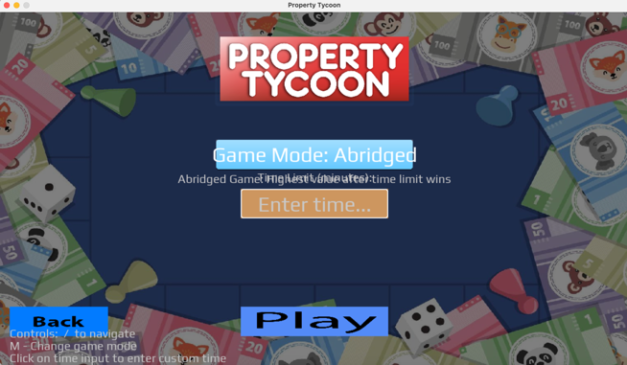
The six images on display highlight what we managed to implement visually based on the task cards we created.

The top two images display the user’s ability to now choose what time they want, as there are no preset time limits restricting them. The default time when first opening the game is 30 minutes, but I didn’t include this image., instead, I showed the underlying message if you remove the default 30-minute timer, which is ‘Enter time…’. We thought this would be a good prompt to the players as it is straightforward and is hard to misinterpret when combined with the text underneath that states how long the game will last.
We will fix the issue that is present in the image, where the text overlaps and isn’t clear to read. This will be fixed during our major UI overhaul.
The central left image shows the AI player agent’s mid game. We have managed to develop them to play the game competently, and their money and position on the boar updates the same as if they were a human player. This is only at the start of the game, but as the game goes on for longer you can see what properties they own and their current cash amount.

The image central right displays both task 1 and task 2. This is the UI that is shown during an auction, showing how long the player has left to bid; what property is being auctioned; the player’s current bid; the minimum bid they are allowed; and the option to submit their bid, or to pass on the property. There are a few bugs that have been discovered regarding this, but overall, it works well and accurately provides the players with the information they need.

The bottom two images show what happens when you press the ‘pause’ button (left) and the results of pressing the ‘leave game’ button (right).
When pressing the pause button during the abridged version, the timer stops and the game pauses, as expected. A notification is displayed to let the players know who has paused, and the game is paused until the ‘continue’ button is pressed. When resuming, the game continues where it left off.
The ‘leave game’ button is our implementation of the quit feature we wanted to add. We didn’t fully succeed in our attempt to have the game calculate the winner based on the current situation, as the person quitting effectively is declaring bankruptcy, so even if they were doing the best, they can’t win. Instead, the game calculates the winner based on the remaining players, so we may need to investigate this and add another feature. If the game is being played with multiple AI game agents and the human player quits, the game will continue as normal, just without the influence of the human player.

- Test plan and evidence of testing

Similar to the previous two sprint cycles, formal testing has not been included. At first, we were going to include unit testing into this sprint, but we decided against it after a long discussion. Our plan is to instead have our fourth, and possibly final sprint, dedicated mostly to testing and some final bug fixes.
We did ensure that the code worked visually and there were no major errors thrown whilst running the game, which did enable us to find multiple bugs that we fixed on the go. Aside from these few bugs, everything looked as we thought it would at this stage in development.
Furthermore, we continued to test the game as a full team to check how everything was running and how the game functioned when having multiple human players playing, as well as watching how the AI would play against each other.
However, we do realise that these aren’t formal ways of testing, and we will make sure to include this in our next sprint.

- Summary of sprint

For this sprint, we successfully achieved our task cards, although to varying extents. Overall, each task card was completed to an acceptable and good standard, however, there are areas of improvement we will need to address in the coming weeks.
This sprint was our most complex sprint so far, with some bigger and more complicated user stories to complete, so errors were always expected. We did plan for this and didn’t let it affect our morale as we knew they would come and were ready for them. None of the errors are major however, just small things that we will tweak.
The main task card we didn’t complete was task 8. This was due to a lack of time for the size of this task when combined with the time required for the other tasks. We underestimated how long the other tasks would take, which didn’t leave us with enough time to complete this successfully. Even though this is a setback, it is not drastically detrimental to our overall progress as we know that we have enough time left with the assignment to achieve this task. We planned to have setbacks like this, so the slack time we have given ourselves can be used to update and overhaul the UI.
So, for the most part, we are very pleased with the results of this sprint and are preparing to tackle our next sprint.

The working prototype has been improved upon nicely and is continuing to get better and better as the days and weeks go by. The auction and AI game agents were our main concern for this sprint, and we have managed to implement them both successfully during this sprint. Whilst running the game, they appear to work correctly and competently, with our future sprint hopefully confirming this with the introduction of testing.

When reviewing the sprint as a team, we thought that the results were very progressive, and we were collectively very happy with it as a team. Although one of our bigger goals wasn’t achieved, the rest of them were achieved and we didn’t let any setbacks or bugs dishearten our progress. The bugs we did encounter were dealt with quickly and smoothly, allowing us to continue with development.
One thing we did notice was that a lot of our tasks focus on making the game ‘fun to pay’, with a ‘colourful and intuitive interface’. Considering this is only a small part of the brief, we were confused as to why it felt that most of our task cards addressed this. Upon reflection and discussion, we determined that even though it was only a small part of the brief, it is a major component of the actual game because nearly every part of the game requires some sort of interface to show the player what is happening. Without it, the game wouldn’t work.
Some things that didn’t go as well as we hoped were:
- Task 6, the text isn’t always clear as it overlaps. This is a common bug we have found in multiple areas of the game and will be addressed.
- The auction system was inconsistent with the displaying of property names, sometimes it would show the wrong property as the auction system wasn’t tracking the players movement correctly. This has since been fixed.
- We found that the messages shown from the log would be confused between the AI and the human player, showing the human player making decisions when it was actually the AI game agents turn. We have fixed this but was a weird bug.
- In the first implementation of the auction system, we found that the AI player agents were unable to bid for properties. This has also been fixed.
- We also found that sometimes the game would freeze or crash when calling some of the new features, such as the auction and pause features. This is an annoying bug as it means we lose all progress. The reason for the crashing we do not know and are still in the process of discovering the root of this problem and solving it.
Asides from these few bugs and some other small ones, the outcomes were desirable, except for task 8, which will be postponed for our fourth sprint.
We learnt that we need to plan what tasks we need to do a bit more thoughtfully if we are to avoid running out of time again, as we did with task 8. However, this is an easily achievable fix which we will consider when planning out the next sprint. We have already begun discussing the next tasks for the fourth sprint, and what we want to improve upon from this sprint, so it has been a very productive sprint.

We have received feedback from Mr Raffles representatives during seminar sessions, where they have expressed delight in what we have produced so far. Their main concern was the UI and overlapping text, which we completely understand and are preparing to fix. They are happy with what we have produced so far, which was pleasing for us to hear. We have also been keeping a keen eye on the discussion forums for any questions and answers as they could potentially help us out.

To conclude, this sprint did throw us a few unexpected challenges, and wasn’t completed fully due to task 8, but it was a successful sprint and we achieved the majority of our user stories to a high standard.

